East Valley Resource Guide

Shelter | VI-SPDAT | Food Box & Hot meals | Clothes/Laundry | Mail | Employment | ID | hotlines

shelter/Men & women: Central arizona shelter system (CASS)
Brian Garcia Welcome Center
Phone: (602) 229-5155
Address: 206 S 12th Ave, Phoenix, AZ
The Human Services Campus is a place where several social service agencies are located in one place, CASS is the emergency shelter program for men & women. To enter CASS for the first time, you have to do an intake at the Welcome Center.
Welcome Center Hours: Weekday 7:30am-11:00am, 12:30pm-5:00pm. Arrive early and sign in so you’ll be among the first to be seen.
New Client: After signing in, a Resource Specialist will do a housing assessment with you. This may qualify you for a housing program later on. After that’s done, you’ll be given a campus ID card. This will give you access to the services on the campus, including CASS.
If you’ve never been in CASS before, staff will check periodically for vacancy throughout the day. You’ll then be referred to CASS for an intake.
If you don’t get in the first day, keep coming back and asking them to check for a vacancy. Since you’ve never been a CASS resident, you’re given priority over returning clients.
Returning CASS residents need to check in at CASS at 3:00pm daily. It’s best to line up around 2:30pm. New clients should also line up if they haven’t been assigned a bed by 3:00pm.
Vehicle Pass: If provide your Driver’s License, registration, and proof of insurance, the HSC will give you a parking pass that’s good until 5:00pm. CASS residents that provide the same proofs can get an overnight parking pass. This policy is subject to change.
Service Animal: If you have a service animal, its best to bring documentation, including vaccination records. Once verified, a sticker will be added to your Campus ID, allowing you to enter the campus/shelter with you service animal. This policy is subject to change.

shelter/Men: East Valley Men’s Shelter
Phone: (480) 610 – 6722
Address: 2345 N Country Club Dr, Mesa, AZ
A telephone screening is done before intake. Once completed, call between 7:30am – 8:30am on weekdays to check availability. Usually takes a week or longer to get in.

SERVICES: 4 month emergency shelter program. You’re required to save 75-85% of income. Case management. Communal showers. Hot meals. Sack lunch. Career center. Bicycle purchase/repair shop. Must be able-bodied and capable of working and completing chores. Sex offenders are accepted.

shelter/Men & Women: Tempe I-HELP Shelter
Victor Rojas, I-HELP Coordinator (480) 422 – 8922 | Victorr@tempeaction.org
Tempe Community Action Agency: 2146 Apache Blvd, Tempe, AZ
Call between 8:00am – 10:00am on weekdays to check availability. Walk-in accepted during the same hours. An interview is done prior to entry. Adult men, women, and couples are accepted. If there isn’t room, clients will be referred to other services.

SERVICES: 90 day overnight shelter program. Participants sleep in hosting churches each night. These churches provide a hot dinner and a sack lunch in the morning. Must find your way to the hosting site each night. Case management support. Must be working, looking for work, or receiving income. Saving money (75%), case management, and completing chores is required. Showers available about 3x weekly.

shelter/Men & Women: Chandler I-HELP Shelter
Roxanna Nava, I-HELP Coordinator (480) 963 – 1423, EXT 116 | Roxanna@azcend.org
Azcend: 345 S California St, Chandler, AZ
Call, email, or walk-in Tuesday through Friday morning to check availability. An onsite intake is required before entry. No registered sex offenders. Social service navigation and a Resource Guide are provided when there’s no room. Adult men, women, and couples are accepted.

SERVICES: 90 day overnight shelter program. Participants sleep in hosting churches each night. These churches provide a hot dinner and a sack lunch in the morning. Participants are shuttled to the hosting site each night. Case management support. Must be working, looking for work, or receiving income. Saving money (75%), case management, and completing chores is required. Showers available about 3x weekly.

shelter/Women: Mesa I-HELP Shelter
Phone: (480) 684 – 0645
Paz de Cristo: 424 W Broadway Rd, Mesa, AZ
Call on weekdays to check availability. Calls will be returned between 10:00am – 4:00pm. Participants can arrive at Paz de Cristo around 3:00pm-4:00pm to see if there’s a vacancy. Women only.

SERVICES: 90 day overnight shelter program. Participants sleep in hosting churches each night. These churches provide a hot dinner and a sack lunch in the morning. Participants are shuttled to the hosting site each night. Case management support. Must be working, looking for work, or receiving income. Saving money (75%), case management, and completing chores is required. Showers available about 3x weekly.

Housing Assessment: Paz de Cristo
Allison (480) 620 - 8695
Paz de Cristo: 424 W Broadway Rd, Mesa, AZ
VI-SPDATs are done on weekdays at Paz de Cristo. This assessment may qualify homeless individuals for housing programs.
ELIGIBILITY: Must be an adult actively experiencing homelessness. Families will be directed to the Family Housing Hub.
SCHEDULE: Walk-in/First come, first serve on weekdays 11:00am – 2:00pm. Appointments only 9:00am – 11:00am.

Housing Assessment: Chandler Downtown Library
Library Phone: (480) 782 – 2800. Ask about Community Bridges
Chandler Downtown Library: 22 S Delaware, Chandler, AZ
VI-SPDATs are done at the Chandler Downtown Library by Community Bridges. This assessment may qualify homeless adults for housing programs.
ELIGIBILITY: Must be an adult actively experiencing homelessness. Families will be directed to the Family Housing Hub.
SCHEDULE: Call the library and ask for Community Bridges to schedule an appointment. Walk-in hours are Thursday 12:00pm – 2:00pm. Contact customer service desk for more information.

Food box/Nutrition: Association of Arizona Food Banks
Website: http://www.azfoodbanks.org
AAFB's provides the largest database of emergency food options (food banks, pantries, soup kitchens, shelters, and others that distribute emergency food) in Arizona.

FEATURES: The website details service hours, eligibility, contact info, and more for food pantries, dining halls, and senior centers throughout Arizona.

Hot meal/breakfast: SVDP Dining Hall - Mesa
67 W Broadway Rd, Mesa, AZ (Broadway & Macdonald)
No requirements. No animals
Breakfast is served 9:30am – 11:30am daily.

Hot meal/breakfast & Lunch: SVDP Dining Hall – HSC
1075 West Jackson Street, Phoenix, AZ (Human Services Campus)
No requirements. No animals
Breakfast is served 7:00am – 8:00am on weekdays.
Lunch is served 11:00am – 12:30pm daily except Sunday.

Hot meal/breakfast & Dinner: Andre House
213 South 11th Avenue, Phoenix, AZ (11th Ave & Jackson St)
No requirements. Pet Friendly
Breakfast is served 7:00am on Saturday.
Dinner is served 5:30pm – 6:30pm Saturday through Thursday.

Hot meal/dinner: Paz de Cristo Dining Hall
424 W Broadway Rd, Mesa, AZ (Broadway & Macdonald)
No requirements. No animals
Dinner is served 5:30pm – 6:30pm daily.

Clothes/Mail/Laundry/storage: Clothes Cabin
Phone: (480) 782 – 2800
Address: 1100 N Alma School Rd, Suite 10, Chandler, AZ (Alma School & Ray Rd)
Hours: Tuesday & Wednesday 9:00am – 3:00pm; Thursday 6:00pm – 8:00pm
These services are for people who can’t afford to buy clothes. You may have 5 articles of clothing every 3 months – belts, socks, underwear, shirts, pants, and more. ID needed. If you don’t have an ID, mention Azcend referred you and they’ll let you slide the first time.
ADDITIONAL SERVICES: Mail service, storage locker and weekly laundry service.

employment/Temp & staffing: randstad USA
Website: Randstadusa.com
John Herrington (480) 643 – 2054 | John.herrington@randstadusa.com
Job Types: Contract, Permeant, Temp-to-Perm, and Temporary
Online Job Search: After an account is created, one of our expert recruiters reviews your resume and will contact you if there is an opening that matches your skill sets and experience. If there are no current fits, we'll keep your resume on file and will continue to look out for positions that meet your unique qualifications.

Local Recruiter (Chandler area): John recruits for mostly entry level/forklift material handling jobs. He can make referrals to other representatives throughout the area.

Entry level: $11.00 -$12.00 hourly Forklift: $13.50 hourly
*Must be certified and have 6 months experience within 1.5 years

Qualifications: Reliable transportation, 2 forms of ID (required for employment verification), clean UA, and a willingness to work.

It helps to have a GED or HSD, but it’s not required. It’s harder to find work if you have a felony less than 10 years old.

employment/Job resources: st joseph the worker
LOCATIONS: Tempe & Phoenix
St. Joseph the Worker helps thousands of people secure quality employment each year. Whatever obstacles you are facing, if you are serious about employment, St. Joseph the Worker can help! There are no fees for our services.
ELIGIBILITY: Part/Full-time workers only. 25+ hours weekly/ 90 days guaranteed employment. No commission based jobs, and minimum wage and above wages only. No under the table jobs (state & federal taxes must be withheld from paycheck).

RESOURCES
- Transportation assistance (bus passes/gas cards)
- Required work shoes/boots
- Interview attire
- Uniform assistance
- Basic tools
- Food handlers license
- Safety equipment
- Select certification fees

Darren Strunk, St Joseph the Worker: (602) 810 – 0376 | Strunk@sjwjobs.org
If employed and eligible for resources, contact Darren for help with employment resources. Proof of employment, such as an employer acceptance letter, is required prior to obtaining resources. Other forms of proof are acceptable as long as the employer officially states that you’re employed as permanent or temp-to-hire employee. If unemployed, Darren can help you learn how to find a job, and provide resources as you move from interview to employment.

For job search assistance, visit Daren at the following locations:
Available the first Wednesday of the month at the Tempe Library 12:00pm – 3:00pm
Tempe Public Library: 3500 S Rural Rd, Tempe, AZ 85282
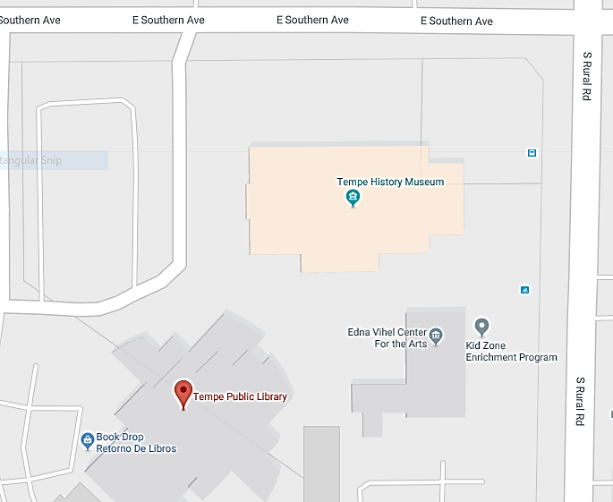
Available the 1st & 3rd Tuesday of the month at the TCAA building 12:00pm – 3:00pm
Tempe Community Action Agency: 2146 Apache Blvd, Tempe, AZ 85281
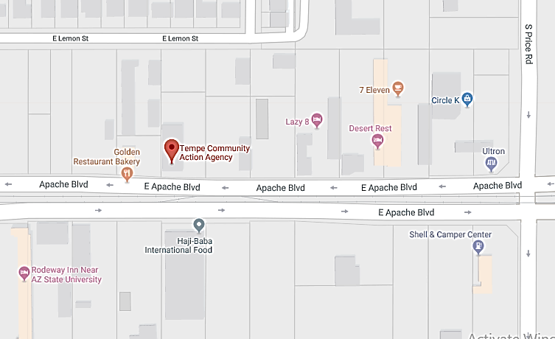
Human Services Campus: (602) 417 – 9854 | info@sjwjobs.org
Monday – Thursday 7:30 am – 11:00 am & 12:30 pm – 3:30 pm
Friday 7:30 am – 11:00 am & 12:30 pm – 2:30 pm
Human Services Campus: 1125 W Jackson St, Phoenix, AZ 85007

REQUIRED:
- State issued Photo ID
- Social Security Card

REGISTER:
- Attend Info Session: Monday – Thursday from 10:00am-10:30am
- Return application provided at Info Session within 5 business days
- You will then work with a Job Developer to determine a specialized job development plan for you based on your individual needs

Mobile Success Unit Outreach Calendar | sjwjobs.org/services/mobile-success-unit/
See website to view online calendar

The Mobile Success Unit (MSU), Arizona’s first ever mobile job development office, is a recreational vehicle designed to literally take St. Joseph the Worker’s employment supplies and resources to job-seekers anywhere in the community.
SERVICES: The MSU mobilizes crucial employment essentials including: computers and internet access to job-search online, create and print resumes; professional clothing and hygiene items; Outreach Employment Specialists to craft a job-search plan and offer job-hunting advice (i.e. successful interview techniques, resume development, etc.) and distribute transportation (bus tickets) to job-search or guarantee transportation to and from work, work uniforms/shoes, tools, and financial assistance for professional certification/license fees.

Identification: homeless id project
Phone: (602) 223-3427
Located inside the Brian Garcia Welcome Center: 206 S 12th Ave, Phoenix, AZ
Hours: 7:30am - 10:00am weekdays
- Procurement of birth certificates and supporting documents necessary to obtain an Arizona ID or driver’s license.
- Purchase of Arizona ID or driver’s license, including transportation to the MVD
- Safe storage of birth certificates and other documents to prevent loss, theft or destruction
Arrive early and sign in. Bring any documents you currently have. Including: Birth Certificate, Social Security Card, AHCCCS insurance card, and IDs from other states.

Identification: Arizona Id & Birth Certificate Vouchers
Phone: (480) 464-2370
Paz de Cristo: 424 W Broadway Rd, Mesa, AZ
Vouchers to help pay for an Arizona State ID and Driver’s License are provided on Tuesdays at 1:00pm at Paz de Cristo. Additional costs (for a Driver’s License, for example) must be covered by the recipient. Vouchers are redeemable on Wednesday & Thursday at the DMV on Greenfield in Mesa. A map is provided.
Help acquiring Birth Certificates is done on Wednesday at 10:00am at Paz de Cristo. Arrive early. Must have a valid photo government ID or have your application notarized. Minimum of 3-4 weeks delivery. It can be mailed to Paz de Cristo, if needed.

Identification: Social Security Administration
Phone: (480) 464-2370
Social Security Administration: 250 N 7th Ave, Phoenix, AZ (7th Ave & Van Buren) AZ
You can get an original Social Security card or a replacement card if yours is lost or stolen. Once you have a plastic (non-temporary) Arizona State ID you can get a replacement Social Security card for free.
REQUIREMENTS:
- Are a U.S. citizen age 18 years or older with a U.S. mailing address;
- Are not requesting a name change or any other change to your card; and
- Have a driver's license or a state-issued identification card from one of the many participating states.

You’ll need to check in and fill out an application first. It will most likely be busy, but they move people through very fast.
Other offices provide card replacements, but the Mesa office does not. Call ahead.

crisis: helpful hotlines
La Frontera / EMPACT-SPC’s 24-hour Crisis Hotlines are available to callers who are feeling suicidal, find themselves in a crisis, have been a victim of sexual assault or domestic violence, and/or need a referral for services.

Face-to-face services are provided by a Mobile Crisis Intervention Team if immediate assistance is deemed necessary. Hotline services are available to all ages and populations within and outside of Arizona.
EMPACT 24-hour Crisis Hotline (480) 784-1500
EMPACT 24-hour Crisis Hotline (855) 785-1500 (toll free)
EMPACT 24-hour Sexual Assault Hotline (480) 736-4949
EMPACT 24-hour Sexual Assault Hotline (866) 205-5229 (toll free)
Rally Point 24-hour Hotline (Veterans and Military) (855) 725-5948

The Crisis Line is available 24/7/365 to anyone experiencing a mental health crisis.
In an emergency, always call 911
Crisis Response Network (602) 222 – 9444
Peer-to-Peer Warm Line (602) 347 - 1100

